**Project Design Phase-II**

**Cloud deployment**

|  |  |
| --- | --- |
| **Date** | **02 November 2023** |
| **Github name** | **[74BC4F37853BF1E8045468DA6E31B6A0-SALESFORCE](https://github.com/Kiruthikaduraiyarasan/74BC4F37853BF1E8045468DA6E31B6A0-SALESFORCE/tree/main)** |
| **Project Name** | Recruiting Assistance For The HR Managers |

**Cloud deployment**

Deploying recruiting assistance solutions for HR managers in the cloud offers numerous advantages, including scalability, accessibility, and cost-efficiency. Here's how you can approach cloud deployment for recruiting assistance:

**1. Select the Right Cloud Service Model:**Choose the appropriate cloud service model based on your organization's needs. The three primary models are:

**- Infrastructure as a Service (IaaS):** You manage the infrastructure while the cloud provider takes care of hardware and data center management.

**- Platform as a Service (PaaS):** The cloud provider manages the entire platform, including the infrastructure and application runtime.

**- Software as a Service (SaaS):** The cloud provider delivers the complete application as a service, with no need for software installation or management.

**2. Choose a Cloud Provider:**Select a reputable cloud provider, such as Amazon Web Services (AWS), Microsoft Azure, or Google Cloud Platform (GCP). Consider factors like data center locations, compliance certifications, and the ecosystem of services they offer.

**3. Scalability and Elasticity:** Leverage the cloud's inherent scalability and elasticity. This allows your recruiting assistance solutions to easily accommodate fluctuations in demand, such as increased hiring activities during specific periods.

**4. Data Storage:**Determine where you will store and manage sensitive candidate and HR data. Cloud providers offer various storage options, including relational databases, NoSQL databases, and file storage systems. Ensure compliance with data privacy regulations like GDPR or HIPAA.

1. **Security Measures:**Implement robust security measures, including encryption, identity and access management, and monitoring. Cloud providers offer a range of security services to help protect your data and applications.

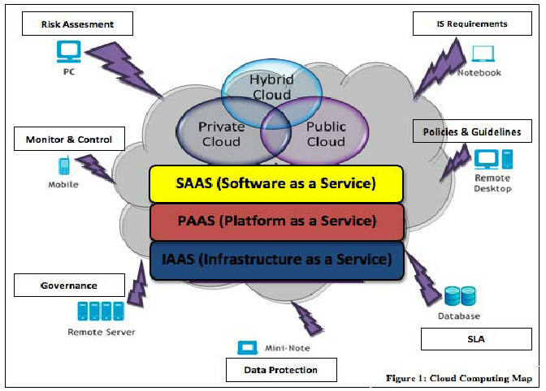

**6. Backup and Disaster Recovery:** Set up regular data backups and disaster recovery plans. Cloud providers often have built-in backup and recovery solutions that make it easier to protect your data.

**7. Compliance and Regulations:**Ensure that your cloud deployment complies with relevant industry regulations and standards, especially when dealing with sensitive HR data.

**8. Integration:** Integrate the cloud-based recruiting assistance solutions with other HR and enterprise systems, such as payroll, HRIS, and performance management tools. Application Programming Interfaces (APIs) and middleware can facilitate integration.

**9. Accessibility:** Ensure that HR managers can access the cloud-based tools from anywhere, using various devices (e.g., laptops, smartphones, tablets). Implement a responsive design or mobile apps for optimal user experience.

**10. Collaboration Tools:** Consider using cloud-based collaboration tools like Microsoft Teams, Slack, or Google Workspace to facilitate communication and collaboration among HR teams and hiring managers.

**11. Cost Management:** Monitor and manage your cloud costs effectively. Cloud providers offer tools and services to help you optimize resource utilization and control expenses.

1. **User Training:**Provide training and support to HR managers to ensure they can effectively use the cloud-based recruiting assistance solutions.

**13. Performance Monitoring:** Use cloud monitoring and management tools to keep track of the performance and availability of your applications. This allows you to proactively address issues.

**14. Updates and Maintenance:** Regularly update and maintain the cloud-based solutions to benefit from new features, security patches, and performance improvements.

**15. Vendor Lock-In:** Be mindful of vendor lock-in and plan for flexibility if you ever need to migrate to a different cloud provider or change your deployment model.

Cloud deployment for recruiting assistance solutions can enhance HR managers' efficiency and enable them to focus on strategic tasks rather than IT infrastructure management. It also provides the agility to adapt to changing HR needs and can be a cost-effective choice for many organizations.